**EXPERIMENT NO. 02**

|  |
| --- |
| NAME: Ayush Vinod Upadhyay  ROLL NO: I025  SAP ID: 60003220131  BRANCH: Information Technology  BATCH: 1 |

**CO/LO:** **Develop web applications.**

**AIM / OBJECTIVE:** Style elements of HTML website using CSS.

**DESCRIPTION OF EXPERIMENT:**

1. `display`: Defines the display behavior of an element (e.g., block, inline, flex).

2. `overflow`: Specifies how content that overflows the element's box should be handled.

3. `flex`: Specifies the flexible length of a flexible container or item.

4. `position`: Sets the positioning method of an element (e.g., relative, absolute).

5. `padding`: Defines the padding space around the content of an element.

6. `inset`: Shorthand for the top, right, bottom, and left properties, specifying the padding or positioning of an element.

7. `background-color`: Sets the background color of an element.

8. `z-index`: Specifies the stacking order of positioned elements.

9. `font-weight`: Sets the thickness of the font characters.

10. `font-size`: Specifies the size of the font.

11. `text-transform`: Controls the capitalization of text (e.g., uppercase, lowercase).

12. `font-family`: Specifies the font family for text.

13. `color`: Sets the color of text.

14. `opacity`: Specifies the transparency of an element.

15. `min-height`: Sets the minimum height of an element.

16. `object-fit`: Specifies how an image should be resized to fit its container.

17. `line-height`: Sets the height of a line of text.

18. `cursor`: Defines the type of cursor to be displayed.

19. `list-style`: Sets the style of list markers.

20. `align-items`: Aligns flex container items along the cross-axis.

21. `justify-content`: Aligns flex container items along the main-axis.

22. `gap`: Sets the gap between flex items.

23. `outline`: Sets the outline of an element.

24. `border`: Sets the border of an element.

25. `min-width`: Sets the minimum width of an element.

26. `outline`: Sets the style of an element's outline.

28. `flex-direction`: Specifies the direction of the flexible items in a flex container.

29. `justify-content`: Aligns flex container items along the main-axis.

30. `align-items`: Aligns flex container items along the cross-axis.

CODE:

<!DOCTYPE html>

<html lang="en">

  <head>

    <meta charset="UTF-8">

    <meta http-equiv="X-UA-Compatible" content="IE=edge">

    <meta name="viewport" content="width=device-width, initial-scale=1.0">

    <link rel="icon" type="image/png" href="/sushi.png" />

    <link rel="stylesheet" href="css/style.css">

    <title>Sushiman</title>

  </head>

  <body>

    <header>

      <nav class="header__nav">

        <div class="header__logo">

          <h4 data-aos="fade-down">Sushiman</h4>

          <div class="header__logo-overlay"></div>

        </div>

        <ul class="header__menu" data-aos="fade-down">

          <li>

            <a href="#menu">Menu</a>

          </li>

          <li>

            <a href="#food">Food</a>

          </li>

          <li>

            <a href="#services">Services</a>

          </li>

          <li>

            <a href="#about-us">About Us</a>

          </li>

          <li>

            <img src="assets/search.svg" alt="search" />

          </li>

        </ul>

        <ul class="header__menu-mobile" data-aos="fade-down">

          <li>

            <img src="assets/menu.svg" alt="menu" />

          </li>

        </ul>

      </nav>

    </header>

    <section class="hero">

      <div class="hero-image">

        <img

          src="assets/sushi-1.png"

          alt="sushi"

          data-aos="fade-up"

        />

        <h2 data-aos="fade-up">

          日 <br />

          本 <br />

          食

        </h2>

        <div class="hero-image__overlay"></div>

      </div>

      <div class="hero-content">

        <div class="hero-content-info" data-aos="fade-left">

          <h1>Feel the taste of Japanese food</h1>

          <p>Feel the taste of the most popular Japanese food from anywhere and anytime.</p>

          <div class="hero-content__buttons">

            <button class="hero-content__order-button">Order Now</button>

            <button class="hero-content__play-button">

              <img src="assets/play-circle.svg" alt="play" />

              How to Order

            </button>

          </div>

        </div>

        <div class="hero-content__testimonial" data-aos="fade-up">

          <div class="hero-content__customer flex-center">

            <h4>24<span>k+</span></h4>

            <p>Happy Customers</p>

          </div>

          <div class="hero-content__review">

            <img src="assets/user.png" alt="user" />

            <p>"This is the best Japanese food delivery service that ever existed."</p>

          </div>

        </div>

      </div>

    </section>

  </body>

</html>

header.css

.header__nav {

  display: flex;

  overflow: hidden;

}

.header__logo {

  flex: 1;

  display: flex;

  position: relative;

  padding: 20px;

}

.header__logo-overlay {

  position: absolute;

  inset: 0;

  width: 100%;

  background-color: var(--primary-color);

  z-index: -1;

}

.header__logo h4 {

  padding-left: 30px;

  font-weight: 700;

  font-size: 24px;

  text-transform: uppercase;

  font-family: var(--playfair-display);

  color: #fff;

  opacity: 0.8;

}

.header__menu, .header__menu-mobile {

  padding: 20px;

  flex: 1.236;

  display: flex;

  align-items: center;

  justify-content: flex-end;

  gap: 64px;

  list-style: none;

}

.header__menu li {

  font-weight: 500;

  font-family: var(--plus-jakarta-sans);

  color: var(--secondary-color);

  font-size: 16px;

  text-transform: uppercase;

  line-height: 20px;

  cursor: pointer;

}

.header__menu li img {

  width: 24px;

  height: 24px;

  object-fit: contain;

}

.header__menu-mobile {

  display: none;

  gap: 20px;

  position: relative;

}

hero.css

.hero {

  display: flex;

  min-height: calc(100vh - 74px);

  overflow: hidden;

}

.hero-image {

  flex: 1;

  display: flex;

  flex-direction: column;

  position: relative;

  z-index: 5

}

.hero-image img {

  width: 120%;

  height: 100%;

  object-fit: contain;

}

.hero-image__overlay {

  position: absolute;

  inset: 0;

  width: 100%;

  background-color: var(--primary-color);

  z-index: -1;

}

.hero-image h2 {

  position: absolute;

  bottom: 0;

  padding: 20px;

  font-family: var(--playfair-display);

  font-weight: 700;

  font-size: 120px;

  line-height: 138px;

  color: #fff;

}

.hero-content {

  flex: 1.22;

  display: flex;

  justify-content: space-between;

  flex-direction: column;

}

.hero-content-info {

  padding: 64px;

  flex: 1;

  display: flex;

  justify-content: center;

  flex-direction: column;

}

.hero-content-info h1 {

  font-size: 80px;

  font-weight: 600px;

  font-family: var(--playfair-display);

  color: var(--secondary-color);

}

.hero-content-info p {

  margin: 32px 0 0 32px;

  font-family: var(--plus-jakarta-sans);

  color: var(--secondary-color);

  font-size: 18px;

  font-weight: 400;

}

.hero-content__buttons {

  margin: 41px 0 0 41px;

  display: flex;

  flex-wrap: wrap;

  gap: 36px;

}

.hero-content__order-button {

  padding: 20px;

  border-radius: 36px;

  min-width: 212px;

  outline: none;

  border: none;

  background: var(--secondary-color);

  cursor: pointer;

  color: #fff;

  font-weight: 500;

  font-size: 18px;

  line-height: 23px;

}

.hero-content__play-button {

  border: none;

  outline: none;

  background: transparent;

  display: flex;

  align-items: center;

  font-size: 16px;

  line-height: 19px;

  color: var(--black-200);

  font-family: var(--plus-jakarta-sans);

  cursor: pointer;

}

.hero-content__play-button img {

  margin-right: 12px;

  width: 46px;

  height: 46px;

  object-fit: contain;

}

.hero-content__testimonial {

  padding: 32px 64px;

  display: flex;

  flex-wrap: wrap;

  gap: 20px;

  background: var(--color-white)

}

.hero-content__customer {

  flex: 1;

  gap: 10px;

}

.hero-content__customer h4 {

  font-size: 62px;

  font-weight: 400;

  font-family: var(--playfair-display)

}

.hero-content__customer p {

  font-size: 16px;

  font-weight: 400;

  font-family: var(--plus-jakarta-sans);

  color: var(--secondary-color);

  opacity: 0.5;

}

.hero-content__review {

  flex: 1;

  display: flex;

  align-items: center;

  gap: 10px;

  padding-left: 20px;

  border-left: 1px solid rgba(2, 2, 2, 0.1);

  min-width: 200px;

}

.hero-content__review img {

  width: 42px;

  height: 42px;

  object-fit: contain;

}

.hero-content__review p {

  font-size: 12px;

  font-weight: 400;

  line-height: 32px;

  font-family: var(--plus-jakarta-sans);

  color: var(--secondary-color);

  opacity: 0.8

}

OUTPUT:

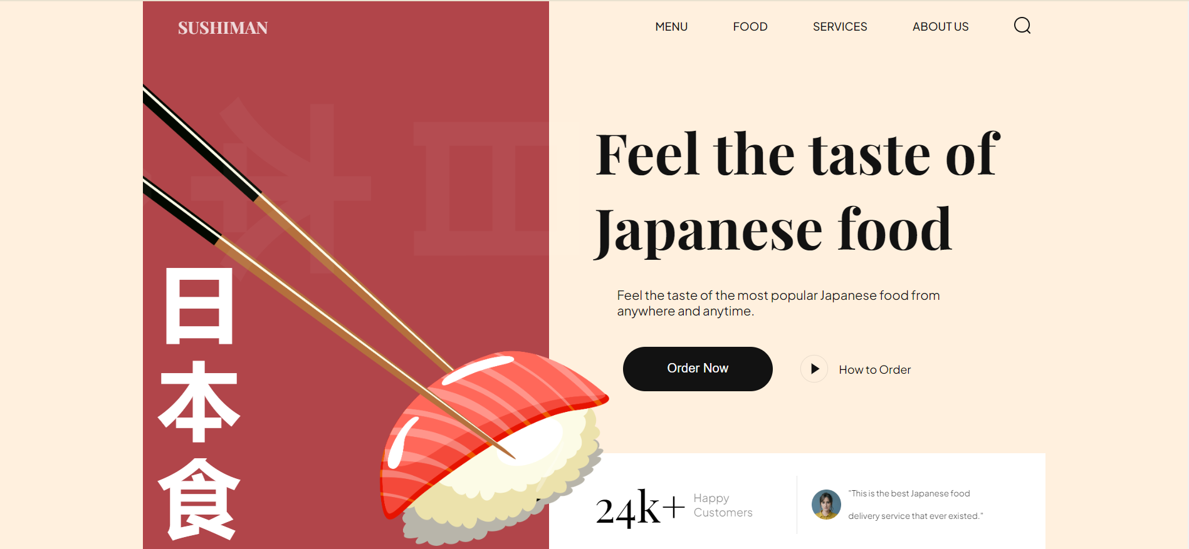

**CONCLUSION:** With the help of Experiment – 2 , I have understood the application of various tags of HTML And style attributes of CSS.

**REFERENCES:** MDN reference https://developer.mozilla.org­­­­­­­/en-US/docs/Web/CSS/Referenc